Dear friends of Art Therapy,
we hope to see you in Norway in 2024 and you are hereby invited to contribute to the content of our 22nd Nordic Art Therapy Conference!
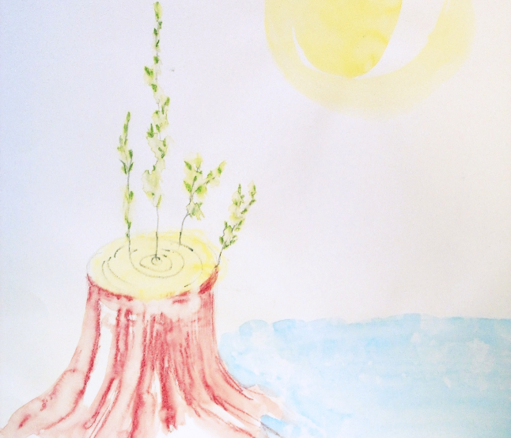
The theme of the conference is:
“Avenues of Hope
and The Power of Art”
We live in uncertain times, and creative expressions are more important than ever. The need to rediscover, create and strengthen hope seems to be crucial, both in a global, a professional and a personal context.

APPLICATION/PROPOSAL FORMAT:
PLEASE NOTE ONLY ONE PROPOSAL PER APPLICANT WILL BE REVIEWED, AND THAT YOU WILL FIND CRITERIA FOR PEER REWIEVING AT THE BOTTOM OF THIS DOCUMENT
Abstract layout for all submissions
- Abstracts should be no less than 250 words and no more than 300 words
- Abstracts should be submitted in English and your own language

In order to assist with the review of abstracts and the publication of the abstracts, the following form is pre-formatted and should not be changed. Authors should carefully observe the following formatting and style conventions:

- Titles should be Arial Bold 14 point single spaced
- Author information should be set two lines below the title and in Arial 11 point. It should consist of three lines single spaced: author’s name, department/school, institution (where appropriate)
- The body of the abstract should be set two lines below your author information
- Font should be Arial 11 point
- Line spacing should be 1.5 with double spacing between paragraphs
- Text should be set left, non-justified, block paragraph/s (no indent)

Name and title

Nationality

Profession and Organisation/ Institution (if applicable):
Email address:

Full postal address:

Telephone number:

Format:  (Please tick) | Paper/Lecture  45 min. | Workshop  2 hrs. | Poster |  | Performance, activity or “happening”
Focus of presentation:  (Please tick) | Research/ Theory | Therapeutic Practice | Education |  | Artistic | Other
Title of Presentation in English:

Abstract of presentation in English:
(no less than 250 and no more than 300 words)

Title of presentation in native language:

Abstract of presentation in native language:
(no less than 250 and no more than 300 words)

Have you presented at an academic/professional conference before? | Yes |  |  | No
Short biography
maximum 150 words

Recent publications and conference presentations:
(maximum 5)

(Please translate to English)

Please indicate if there is a particular period during the conference when it would be impossible for you to give your presentation
Photograph of you
Date of application

The completed proposal document should be sent to:
billedterapiforeningen@gmail.com no later than November 1st 2023
OBS! RENAME THE DOCUMENT WITH YOUR NAME!!

Criteria for peer reviewing
All submissions will be peer reviewed by a professional, Norwegian review board. If selected, the abstracts and the author’s information will go into the conference program and therefore should be fit for publishing.

Administrative use only
Rating Process
Submissions are rated according to the scoring scale given below.

Category | Reviewer 1 | Reviewer 2 | Mod Score
- Title and abstract: clear description of the presentation and its contents
- Conciseness, coherence, and clarity of theoretical, methodological, therapeutic and/or artistic focus
- Relevance, innovation, originality and currency in relation to the conference theme
- Evidence of a high standard of research/ practice /artistry/ education
Total 1 - 4 (score 4-16)

Scores: 1 = Not acceptable | 2 = Acceptable | 3 = Good | 4 = Excellent

Reviewer’s remarks:
(Between 50 and 75 words)

